Cut out the labels, diagrams and descriptions below, then arrange them on your page to explain how substances change state. You will need to draw in most of your own arrows. Glue your pieces in place.
Solid
Liquid
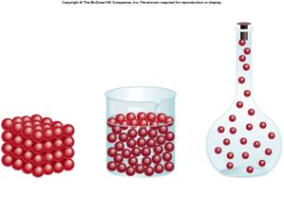
Gas
Melting
Deposition
Evaporation
Sublimation
Freezing
Condensation
(solidification)
(vaporisation)
Boiling
Energy Increasing
Energy Decreasing
The bonds holding particles together in a liquid are just strong enough to hold them together. When heat is added and the particles start vibrating more violently the bonds can no longer hold the particles together

As heat adds energy to the solid, the particles on the edge start to vibrate so violently that they break away from the others.

Some gases change directly into solids without passing through a liquid state.

Where the particles in a liquid lose so much heat they slow down and turn into a solid.

As a gas loses heat energy the particles slow down and attract to each other forming bonds. These bonds hold the particles together in the form of a liquid

Where a solid turns directly into a gas without going through a liquid phase.

A special case where evaporation occurs throughout the liquid forming bubbles. Only happens at the temperature called the Boiling Point.

